**IT2120- Probability and Statistics**

**Lab Sheet 06**

**IT24104168 – Hemakeerthi M.D.M.H.**

1. An IT company claims that their newly developed learning platform improves stu dent performance in online tests. According to previous data, 85% of students who used the platform passed their online tests. A batch of 50 students is selected at random who have completed the course using this platform. Let X denote the number of students who passed the test out of 50 students.
2. What is the distribution of X?

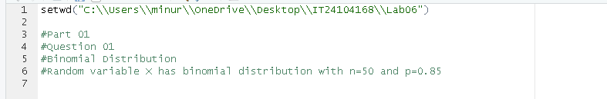

1. What is the probability that at least 47 students passed the test?

1. A call center receives an average of 12 customer calls per hour.
2. What is the random variable (X) for the problem?

1. What is the distribution of X?

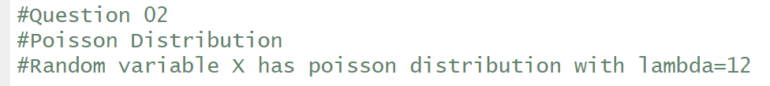

1. What is the probability that exactly 15 calls are received in an hour?

